Outdoor School – 15 Mile Creek

“Educating for Sustainable Living”

ABN: 27 819 095 091

outdoor.sch.fmcc@education.vic.gov.au

692 Benalla-Whitfield Road Greta South, Victoria, 3675 P: 03 5766 6247

Visiting Teachers Booklet
Including all parent/Guardian & student information)

An online version of this booklet can be downloaded at www.outdoorschool.vic.edu.au This Parent & Student Booklet can be translated into various languages using the ‘Translate’ icon in the Review tab when opening in word.

P-12 Curriculum:
- Challenge and grow.
- Leadership.
- Exploring Our Environments.
- Knowing The Environment.
- Future Makers.
- Special School Programs.

Respectful Relationships - Statement of Commitment
  - We commit to action that promotes gender equity & respectful relationships.
  - We will model respectful relationships between peers and all members of the school community.
  - We will speak out about sexism, gender inequity and gender stereotypes.
  - We will provide a safe, inclusive and supportive environment.
  - We will provide a structural and cultural environment that promotes gender equity.

Table of Contents

Before Coming You Must Organise 3
Other Important Parent Information 3
Students' Code of Conduct & Cooperation 4
Specific Rules at the School 5
Personal ICT hardware such as phones 5
Personal Property 5
Parent Consent Form 6
Medical Information Form 7
Asthma Update Form – School Camps & Excursions 8
Action Plan - Allergic Reactions 9
Action Plan - Allergic Reactions 10
Personal Clothing and Equipment 11
Personal Clothing and Equipment – Cont 12
General Information 13
Sample Timetable — 15MC Grade 3&4 15
Curriculum/Program – Adventure Activities 16
Additional Information for Visiting Teachers 18

Before Coming You Must Organise

Code of Cooperation
This must be read and agreed to by the parents/guardians and student. Please take time to acknowledge that Mobile Devices must be left at home.

15 Mile Creek - Consent Form
- Must be read by parent/guardians and students, and then signed by both in conjunction with reading the Code of Cooperation.
- These must be returned to the teacher organising your program as soon as possible.

15 Mile Creek Medical Forms
- These forms must be completed and signed indicating the students’ current medical status with any information requiring specific attention or treatment (e.g. allergies, medications being taken).
- Asthmatic students must bring all medications for their condition to 15 Mile Creek.
- Asthmatic students must complete the attached School Camp and Excursion Asthma Update Form and attach a copy of their Asthma Action Plan. For a copy of any of these Asthma Action Plans, please visit our website at www.outdoorschool.vic.edu.au under Forms and Information Booklets
- Students with allergies must complete the attached Allergic Reactions Action Plan.
- Students that have Anaphylaxis reactions must complete the appropriate attached Epipen Anaphylaxis Action Plan (This plan must be signed by your doctor).

Personal Clothing and Equipment
- Please read through the list ahead of time and pack all the clothing and essentials to be well organised for the program. Also outlined is the equipment 15 Mile Creek supply.
- Please be reminded that the Department of Education and Training does not hold insurance for personal property brought to schools and it has no capacity to pay for any loss or damage to such property.

Other Important Parent Information
The program will contain activities and events which are different from those experienced at school. Qualified and experienced teachers are responsible for the supervision and teaching of all adventure activities and necessary precautions are taken to minimise the possibility of injury.

Parents/guardians should understand however, that all the listed activities do carry risk of physical injury and that accidents can, and do occur. However, Outdoor School has an active and ongoing risk management program whose objective is to provide a safe and effective environment for students and staff.

Activities may include bushwalking, climbing/abseiling, mountain biking, orienteering/rogaining, canoeing, rafting, sledding, pioneering, creek walking, shelter making, woodwork, team initiative activities, working in the garden and the sensory trail course. Many of the activities are conducted in remote locations subject to severe weather and other natural hazards. In the event of injury or illness, communications or emergency services may be limited or not available for periods of time. This may result in delays in injured/sick group members accessing more definitive care. It is important that students are appropriately insured for medical treatment as the Outdoor School, being a State Government School of Victoria, does not have any insurance to this effect.

Parents/guardians are always very welcome to contact the Principal on (03) 5754 1732, or Campus Principal on (03) 5766 6247, should any further information be required.

Students' Code of Conduct & Cooperation

Guiding Principles

  - To ensure that the rights of all individuals are protected whilst at Outdoor School, and to and from Outdoor School.
  - To establish the best possible learning environment.
  - To ensure that breaches of the code of conduct are treated in a fair and consistent manner and within the expectations of staff and students.
  - We employ Restorative Practice principles at our school when dealing with student engagement issues.

Rights | Responsibilities & Expectations
All individuals and their property are to be valued and treated with respect. | All students should treat one another, staff and property with respect.
All individuals have the right to a safe, secure and cooperative working environment in which participation, risk taking and confronting challenges are encouraged. | All students should act and behave in a way which does not endanger, intimidate or interfere with the participation of others.
All individuals have the right to privacy. | All students should respect others rights to privacy.
Staff should be able to perform their duties in an atmosphere of order and cooperation. | Students should comply with instructions given by any members of staff and should willingly participate in the daily routine of 15MC.
Staff, students and the natural environment have the right to exist in a healthy and environmentally considerate atmosphere. | All students should conduct themselves in a healthy and environmentally friendly manner towards other students, staff and the natural environment.
15MC expects support from all students, parents/guardian, and staff in implementing this Code of Conduct & Cooperation. | All students should behave according to this code and accept the consequences if it is breached. All staff should fairly, reasonably and consistently implement this code. Staff and parents of participating schools should support 15 MC in implementing the Code of Conduct & Cooperation.

Implementation Process

The School has developed levels of appropriate responses and sanctions. Any breach of the Code of Cooperation will initiate a restorative approach. The staff will decide the appropriate level of action. Students may be withdrawn from 15MC under certain circumstances.

Specific Rules at the School

Specific rules at the school: -
To respect the rights and expectations of all individuals at the school the following forms of behaviour are considered a breach of the code and are therefore unacceptable:

- Bringing cigarettes, alcohol, non-prescribed drugs, offensive weapons, and pornographic material.
- Using language which is offensive, sexist, genderist or racist.
- Fighting, bullying (physical, verbal, indirect or cyber) or any other forms of aggressive behaviour.
- Being in the lodges/room of other sexes.
- Being in another student’s room without permission.
- Leaving 15 Mile Creek Campus boundaries without permission.
- Behaving in a manner which damages or vandalises the property of others or the environment.
- Climbing of trees, buildings or other structures without teacher supervision.
- Students bringing deodorant sprays – health precaution.

Personal ICT hardware such as phones

Mobile telephones, IPods and tablets are not to be brought to 15 Mile Creek.

To maximise student learning we expect students to disconnect from all mobile devices for their time at 15 Mile Creek. This allows students to engage with their peers, and the outdoor experience.

Any mobile devices that are brought to 15 Mile Creek, will be collected by staff upon arrival and stored in a secure place.

If needing more information, you may access a copy of our policies including:

  - Personal Mobile ICT Devices Policy
  - Child Safety Policy
  - Mandatory Reporting Policy
  - Student Wellbeing and Engagement Policy

from our website via the following link http://www.outdoorschool.vic.edu.au/policies/3699/

Personal Property

Please Note: - The Department of Education and Training which includes Outdoor School does not have accident insurance. Items of personal property that are lost, stolen or damaged at school will not be the responsibility of Outdoor School or the Department. Staff and students are reminded not to bring items of value to school

Outdoor School – 15 Mile Creek
Parent Consent Form — Valid 2022

Student’s Full Name: ______________________________________________________________________________________

Parent/Guardian Consent – please circle response below as appropriate – (if left blank we will assume yes is the response):
The information about your child/dependant and family collected through this Enrolment Form will only be shared with school staff who need to know to enable our school to educate or support your child/dependant, or to fulfil legal obligations including duty of care, anti-discrimination law and occupational health and safety law. The information collected will not be disclosed beyond the Department of Education and Training without your consent, unless such disclosure is lawful. For more about information-sharing and privacy, see our school’s privacy policy: Data will be kept permanently as per the 2018 Retention and Disposal Authority for Records of School Records 3.3.1 Summary Enrolment Records requires. The collection and use of the students personally identifiable information via consent forms provided within the handbook and stored via Cumulus is done in accordance with the Privacy and Data Protection Act 2014. Data will be kept permanently as per the 2018 Retention and Disposal Authority for Records of School Records 3.3.1 Summary Enrolment Records requires.
I agree to my child/dependant using the internet and computer network at 15 Mile Creek in accordance with the same internet student user’s agreement that applies at their current school. | Yes | No
I also consent to my child/dependant being photographed and/or visual images of my child/dependant being taken whilst at 15 Mile Creek by the DET. I also consent to these photos being used for use in the school’s publications, the school’s social media accounts and the school’s website, for publicity purposes without acknowledgment and without being entitled to any remuneration or compensation. | Yes | No
Is English your child/dependant’s main language? | Yes | No
Is your child/dependant of Aboriginal or Torres Strait Islander origin? | Yes | No
Has your child/dependant been away from home before? | Yes | No
I authorise the teacher in charge to administer paracetamol as per the Outdoor School protocol. | Yes | No
Subject to availability, I authorise Outdoor School to provide my child/dependant with a Rapid Antigen Test. | Yes | No
I understand that I will be required to immediately collect my child/dependant from Outdoor School if they display any covid symptoms or return a positive Rapid Antigen Test while on program. | Yes | No

I agree to my child/dependant's attendance at the Outdoor School – 15 Mile Creek on _______/________/__________ (Starting Date)
I also agree to them taking part in any excursion or activities arranged for students in connection with the school program. I have read the Parent/Guardian & Student Booklet and understand the program contains potentially hazardous activities in remote areas subject to natural hazards and severe weather.
I will notify the school if my child/dependant is in contact with any infectious disease within four weeks of departure date. In the event of any illness or accident, where it is impracticable to communicate with me, I authorise the teacher in charge to consent to my child/dependant receiving such medical or surgical treatment as may be deemed necessary. I accept responsibility for payment of any expenses thus incurred. In the event of my child/dependant being unable to accompany the rest of the group home due to ill health or accident I will make the necessary arrangements in liaising with the School Principal for their return.
I agree to ensure that my child/dependant’s mobile devices (phones, tablets, iPods etc.) remain at home whilst they attend this program.
Should my child/dependant violate the rules of the school to the extent that the teacher in charge in consultation with the Principal of Outdoor School 15 Mile Creek considers that they should be sent home, I agree to organise this withdrawal and fully cover the transport costs involved in this process.
________________________________________________________
Parent/Guardian's Full Name (please print)

________________________________________________________ __________________
Parent/Guardian's Signature Date

I have read the Outdoor School Student Code of Cooperation and I hereby undertake that while travelling to and from the school and while in attendance I shall behave in a good and proper manner and shall observe whatever rules are decided on as best for the welfare of all.

________________________________________________________ __________________
Student’s Signature Date
Cancellation or Withdrawal
The Department of Education and Training (DET) reserves the right to cancel a program for any reason. In the event of a student's application being withdrawn prior to the commencing date of the program the DET through the Principal reserves the right to make a refund only where a reasonable excuse for withdrawal is offered. No refund will be made where a student leaves during the program except in the case of illness, and then only on a pro rata basis.
Outdoor School – 15 Mile Creek

Medical Information Form — Valid 2022

This information is intended to assist Outdoor School in case of any medical emergency with your child/ward. All information is held in confidence.
School: |  |  |  |  |  |  |  | Year Level / Visiting Staff:

Student Full Name:
Student Date of Birth: |  |  |  |  |  | Student Gender: |  |  |  | Female |  |  |  | Male |  | Gender Diverse

Parent/Guardian Full Name:
Address: |  |  |  |  |  |  |  |  |  |  |  | Postcode:
Parent/Guardian Mobile Phone: |  |  |  |  |  |  |  |  | Other Phone:

Home Email Address:
Medicare No: |  |  |  |  | Valid to: |  |  |  |  |  | Child’s Number (eg. 2): 4):
Health Insurance Fund: |  |  |  |  | Member No: |  |  |  |  |  | Ambulance Subscriber: |  |  |  |  |  | Yes | No

Tick | Item | Details
 | Diabetes
 | Dietary Requirements
 | Dizzy Spells/Blackouts
 | Fits Of Any Type
 | Hay Fever
 | Heart Condition
 | Migraines
 | Physical Difficulties
 | Previous Injuries - When
 | Sleepwalking
 | Travel Sickness
 | Other
 | Bed Wetting

Please tick the box on the left if your child/ward suffers any of the following:
 | Anaphylaxis | If ticked, you MUST attach the appropriate completed Anaphylaxis Action Plan.  Please state below who will be responsible for carrying the Epipen?  Responsible person is:
 | Allergies | If ticked, you MUST complete and attach the Allergic Reactions Action Plan
 | Asthma | If ticked, you MUST complete and attach Asthma Update Form along with your child’s  personal Asthma Action Plan.

Year of Last Tetanus Immunisation (If known):

Medication – Is your child/ward presently taking tablets and or medicine? YES / NO (If yes please detail below.)
Condition | Medication | Dosage | When given & instructions.
Swimming Ability: please tick the distance your child/ward can swim comfortably.
 | Cannot Swim |  | Weak Swimmer  (<50m) |  | Fair Swimmer  (50-100m) |  | Competent Swimmer  (100-200m) |  | Strong Swimmer (200m+)

______________________________________________________________ ___________________
Signature of Parent/Guardian:
DET requires this consent to be signed for all students and teachers attending school excursion

Asthma Update Form
Page 8 of 21

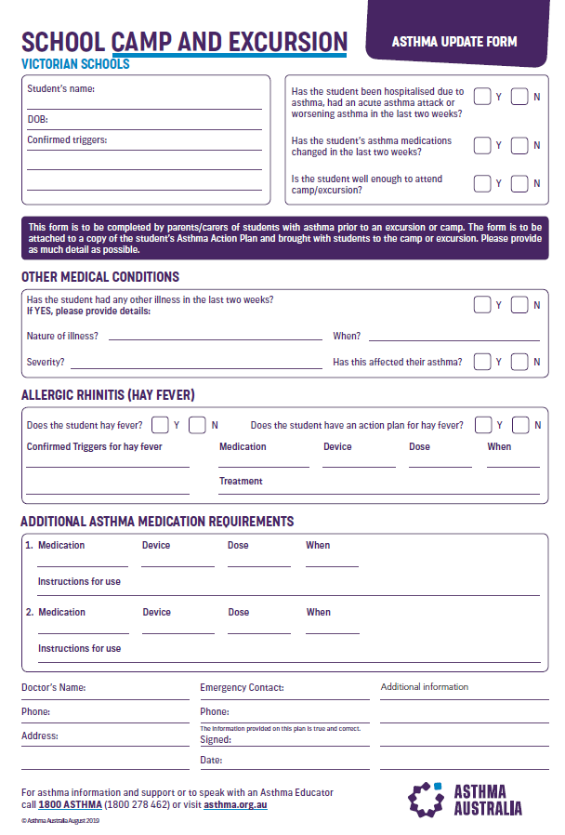

Action Plan - Allergic Reactions

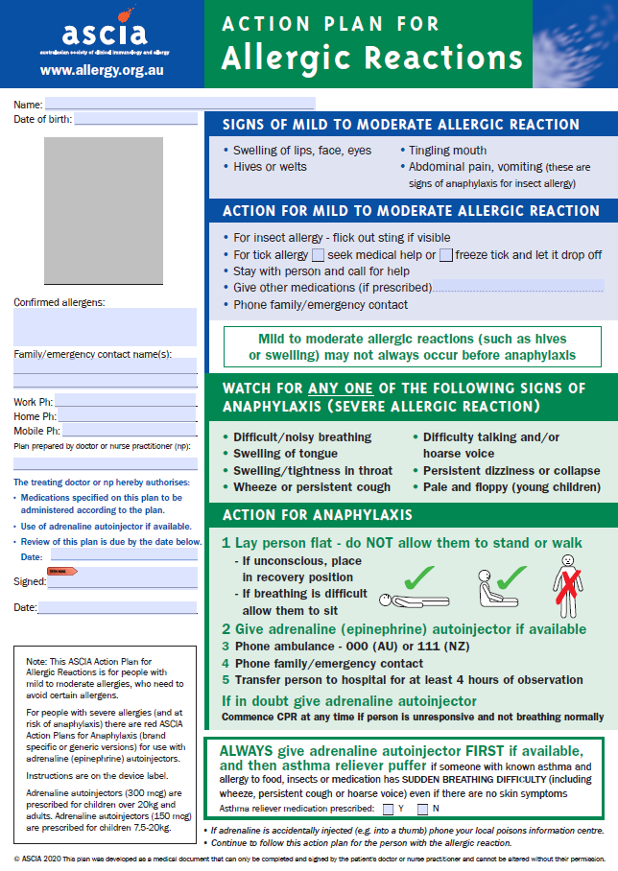
Action Plan - Anaphylaxis Reactions

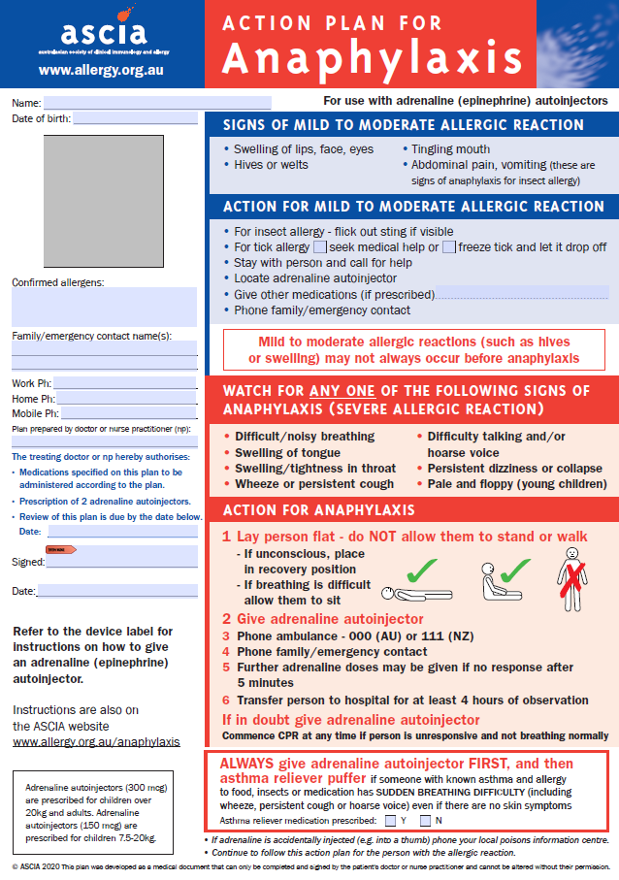

Personal Clothing and Equipment
This list provides information on the types of the clothing and other essentials that you should bring. It also outlines the equipment supplied by 15 Mile Creek.

Clothing
- 2 or three pairs of long pants (tracksuit/jeans)
- 1 or 2 windcheaters
- 1 or 2 pairs of shorts
- 1 pair of bathers
- Handkerchiefs
- Sunhat –broad brimed bucket – no caps
- 1 Pair Mittens or Gloves
- Beanie
- 2 Pairs of runners – (normal wear pair and old pair for aquatics)
- 2 or 3 long sleeve shirts or thermal tops
- 1 or 2 warm jumpers (polar fleece or woollen preferred)
- 3 or 4 T-shirts
- 4 sets (top and bottom) Underwear
- 4 Pairs Socks – (thick)
- 2 pair Pyjamas
- 1 warm parka or jacket

Toiletries
- Soap, toothbrush, toothpaste, hairbrush, roll-on deodorant (please do not bring spray deodorant), face washer.
- 2 Towels
Linen
- Sleeping Bag for sleeping indoors at 15 Mile Creek, (where applicable an Alpine Sleeping Bag will be provided by 15 Mile Creek for overnight hikes)
- 1 pillow

Other Items
- Sunglasses & sunscreen
- Lip Balm
- Drink bottle
- Torch (small with new battery)
- Personal medical requirements
- Optional items - Book for personal reading, camera (not a phone or iPod), cards, games, thongs & insect repellent

15 Mile Creek Supplied Gear
- Fitted sheet
- Waterproof jackets
- Waterproof over pants
- Lunch box and drink bottle
- Day-packs
- Specialist equipment (tent, sleeping bag, backpack, helmet etc.) are all provided.

Please Note:
  - Schools who attend late Term 2 or early Term 4 (possible winter conditions) should make sure to bring extra warm clothing to their program.
  - All personal items and luggage should be clearly marked with the owner's name. The DET does not hold insurance for personal property brought to schools and it has no capacity to pay for any loss or damage to such property.
  - Try to utilise clothes and other items you have at home rather than buying anything special for the program.
  - No money is required at 15 Mile creek, there is no facility at 15 Mile Creek to spend money.
  - Outdoor School 15 Mile Creek is a Sunsmart School. Students are required to wear a hat from September to April (UV levels 3 or above). Students will also be encouraged to wear clothing with long sleeves and collars, to wear suitable sunglasses and to apply sunscreen.
  - Students are not to bring deodorant sprays as they can set off the emergency fire alarm. Bring a roll-on deodorant instead.
  - No personal ICT devices are permitted at 15 Mile Creek.

Personal Clothing and Equipment – Cont.
If your school has incorporated an overnight bushwalk into your program, then the items on the Personal Student List below need to be brought to 15MC.

Bushwalking & Camping Clothing & Equipment List
Personal Student List  Supplied by Students | Individual Student List  Supplied by Outdoor School | Group List for pairs  Supplied by Outdoor School
- Thermal Underwear  - long johns  - top  - Warm Jumper x 2 (Polartec or Woollen)  - Long Sleeved Shirt (not cotton)  - long pants  - Tracksuit Pants – 1 pair (To sleep in) (Synthetic type OK)  - Gloves  - Socks – 3 pair (Woollen/Synthetic mix)  - Underwear  - Beanie  - Peaked Cap/Sunhat  - Sunglasses  - Sunscreen & Lip Balm  - Plastic bags x 4 (30cm x 30cm)  - Water bottle  - Small Torch - spare batteries  - Personal Medication  - Camera | - Rucksack  - Rucksack Liner  - Sleeping Bag  - Sleeping Bag Liner  - Mat (for sleeping)  - Waterproof Jacket  - Waterproof Overplants  - Mug  - Plate  - Bowl  - Knife, Fork, Spoon | - Tent & Fly  - Pegs  - Stove  - Fuel Bottle  - Waterproof Matches  - Water Bag  - Toilet Paper  - Food Bags  - Food supplies

Staff Leader’s Equipment List

First Aid Kit

Foam Mat

Mobile Phone/Radio/Satellite Phone & Spot Device

Map & Compass

General Information
Outdoor School is owned, staffed, and funded by the Department of Education and Training (DET) and provides programs for Years P– 12 students from Government Schools throughout Victoria.

Centre Location
Outdoor School, 15 Mile Creek (15MC) is located on the country of several Aboriginal language groups 220kms northeast of Melbourne and is nestled in a scenic rural valley in the foothills of the Great Dividing Range. Closest major centres are Wangaratta 42km & Benalla 32km. The 15MC property consists of 110 hectares of unspoilt bush adjoining state forest.

Program
Programs provided at 15 Mile Creek vary from school to school depending on the school’s needs. The programs come under the following broad categories. Challenge and Grow, Leadership, Exploring Our Environment, Knowing the Environment, Special School Programs and the Future Makers Program. All programs make extensive use of Outdoor Adventure activities as outlined below.

Programs include
Site based adventure activity programs, including activities such as:
- Archery
- Aquatics
- Bike Riding
- Bushwalking
- Rock-Climbing
- Initiatives
- Orienteering
- Flying Fox
- Bush Cooking and Bush Hut building as well as other outdoor educational pursuits.

Offsite extended trips camping in tents, as well as offsite extension activities such as canoeing and river activities on the King, Murray and Goulburn Rivers and Lake William Hovell.

Physical fitness for the program
The activities undertaken can be strenuous and it is strongly advised that students and visiting teachers have a reasonable level of fitness in preparation for their time at 15 Mile Creek.

Accommodation
Students and visiting teachers (VT’s) are accommodated across 4 buildings as required, this includes two dormitories that are divided into smaller rooms, each dormitory can accommodate 18 students & two visiting teachers. The other separate accommodation buildings can accommodate up to 10 students and a visiting teacher in each. Dormitories are furnished with bunk beds, mattress, and cover sheet. Students and VTs are required to bring their own sleeping bag and pillow. All buildings are heated and facilities include bathrooms, indoor and outdoor recreation areas, drying rooms and dining room. Facilities (i.e. wheelchair ramps and specialised bathrooms/toilets) are provided to some accommodation for students with physical disabilities.

Catering
Outdoor School employs a catering manager and a catering assistant who provide all meals and aim to specifically cater for the dietary needs, tastes and appetites of students. All dietary requirements can be catered for – please ensure you accurately complete the dietary information section on your child’s medical form. During the program 15MC will provide all food and dietary requirements, students and visiting teachers should not bring any food to 15MC. For catering purposes, the actual numbers of students and staff from each school needs to be confirmed on the Cumulus online portal two weeks in advance with any special dietary requirements.

Transport
Visiting schools need to arrange for return coach transport between the school and 15 Mile Creek. Local transport during the program may be either self-drive using Outdoor School vehicles, or by coach.

Outdoor School, 15 Mile Creek Staff
15MC is staffed and operated by the Department of Education and Training (DET). Currently the staffing profile consists of a Principal, Program Coordinator, nine Teachers, and Business Manager. 15MC also has a Facilities Maintenance Manager, Catering Manager and assistant, Grounds Person and a Cleaner.

Reports
At the conclusion of the program 15 Mile Creek teachers will write reports for each student. Some programs may receive certificates.

Telephone
Inward phone calls are received between 8.30am and 4.30pm on the office line (03) 5766 6247. After hours there is telephone access in the kitchen on telephone number (03) 5766 6137. Outdoor School has an answering machine in operation at times when the office is unattended. An outside of business hours’ number 03) 5766 6137 can be used between 10pm and 7:30am. Outgoing calls can be made by visiting staff if necessary. Mobile telephone reception is limited in the area; all 15MC staff have mobile telephones and UHF radios for use during programs and satellite phones.

Student telephone use:
  - Students are discouraged from calling home during the program.
  - Students are to leave their personal mobile devices at home, they are not required at Outdoor School – Outdoor Schools Personal Mobile ICT Devices policy for students can be found on the website of by following this link
http://www.outdoorschool.vic.edu.au/wp-content/uploads/2018/03/Personal-Mobile-ICT-Devices- Students.pdf
  - If mobile phones are brought to Outdoor School, they will be collected and stored in a secure location until the end of program.

Emergency Telephone Numbers
15MC (Office) | 03 5766 6247 | Principal – Tony Keeble | 0417 541 732
15 MC (After Hours – Kitchen) | 03 5766 6137 | 15MC Principal – Rhys Evans | 0428 789 338

Sick Students
15MC has a well-equipped sick bay for dealing with day to day first aid needs. Should a student(s) be unable to take part in the program, then a staff member or their visiting teacher may be required to supervise them at the Campus.

Fees
Please contact your home school contact for details of the cost per student or if required contact 15 Mile Creek on 03 5766 6247 or via email outdoor.sch.fmcc@education.vic.gov.au.

Timetable
Outdoor School is highly organised, with students under instruction most of the day, leaving little free time. 15MC operates as an educational institution (not a holiday camp) and has a curriculum designed to complement that experienced at school.

Curriculum/Program
A description of 15MC’s Activities including photographs can be viewed on Outdoor School’s home page. Likewise details about the types of programs conducted can be viewed on the 15 Mile Creek ‘Curriculum & Learning Programs’ page of the website (www.outdoorschool.vic.edu.au).

Personal Clothing & Equipment
Dress during the time at 15MC should be informal and practical. However, be prepared for great variation in temperature, even in summer. The list will give you some idea of the clothing and other essentials that you should bring.
Schools who attend late term 2, throughout term 3 or early term 4 (possible winter conditions) should make sure that extra warm clothing is brought to 15MC.
Students will be provided with a waterproof jacket and over pants, day pack and a lunch box for their personal use while at 15MC. On programs where hiking is included, all hiking gear, including sleeping bags will be provided by 15MC.

Students Code of Conduct
Students participating in programs are expected to act in a manner conducive to the wellbeing of property, other people and the natural environment. As such they should acquaint themselves with the student code of conduct.
Student Engagement, Mandatory Reporting & Child Safe Policies
Outdoor School has a student engagement, mandatory reporting and child safe policies. These are available on the schools website at http://www.outdoorschool.vic.edu.au/policies/3699/

Consent Form
This form must be read carefully by both parent/guardian and student and signed by both then returned to the school before a student can attend the program.

Medical Information
It is in the best interest of parents or guardians to include as much information as possible regarding a student's current medical status especially any information requiring specific attention or treatment (e.g. allergies, medications being taken, dietary needs etc.).

- Asthmatic students should ensure that all medications needed for their condition are brought to 15MC. Asthmatic students should bring an Asthma Management Plan with them from their doctor. Severe asthmatics or students who have been previously hospitalised from asthma should see their doctor before coming for their advice as the weather at 15MC can be damp, and cold at any time. Asthmatics need to complete the Outdoor School Asthma Management Form.

- Students with Allergy or Anaphylaxis should ensure that all medications needed for their condition is brought to 15MC. Allergy or Anaphylaxis students must bring an Action Plan for Allergy or an Action Plan for Anaphylaxis with them from their doctor. This also applies to the Anaphylaxis and Allergy Management forms.

Sample Timetable — 15MC Grade 3&4
A general guide for a typical day at 15 Mile Creek with approximate times.

7:00am | Lights on
7:45am  8:20am | Breakfast  Dormitory/room clean up
8:50am | Morning assembly
9:00 – 12:15pm  12:30pm | Morning activity sessions  Lunch
1:30pm | Afternoon assembly
1:45pm – 4:30pm  4:30pm – 5:30pm | Afternoon activity sessions  Showers/Dinner preparation
6:00pm | Dinner
7:00pm  7:15 – 8:30pm | Evening assembly Evening activity session

The visiting teachers (VTs) are responsible for the supervision of students between lights out (10:00 pm) and 7:30 am the next morning.
Times vary depending on age groups and programs.

Curriculum/Program – Adventure Activities
Below is a brief description of some activities that may be in your program. Many of the activities are conducted in remote and rugged locations and in environments subject to severe weather and other natural hazards. In the event of injury or illness, access to communications or emergency services may be limited or not available for significant periods of time. This may result in delays in injured or sick group members accessing more definitive care.

ABSEILING AND ROCK CLIMBING
Suitable for middle primary aged students through to adults, these activities are conducted under qualified instruction by 15MC teachers. We have a purpose built 10 metre tower on site for these activities.
Abseiling and Rock Climbing Extension - students may be involved in belaying other students under active supervision and after training and assessment by teachers. Some students are taken to a site in the King Valley where they have the opportunity to extend the climbing and abseiling they have done at the Campus. This is normally done as a half day activity.

ARCHERY
The archery area is located within the 15MC fenced in grounds. Targets are set up permanently and we have up to two students at one time shooting. Grade 2 and older can complete this activity.

BIKE RIDING
Bike Riding is conducted on riding tracks that are within the 15 Mile Creek property. Tracks have varied degrees of difficulty.
Bike Riding Extension - On occasion some bike riding programs for older students are run at offsite locations.

Teachers conduct bike riding lessons for all age groups (BMX bikes for primary students, mountain bikes for secondary students)

BUSH WALKING
There are a variety of walks available at 15MC to cater for all abilities. Bushwalks range from short walks within the 15MC site to extended walks beyond the 15MC site boundaries, including overnight trips. We have a network of easy to navigate four-wheel drive and walking tracks within the 15MC property as well as wilderness walks requiring map reading skills. Offsite bushwalks involve students hiking in groups of 12, accompanied by one 15 Mile creek teacher and one Visiting Teacher. Walks can visit a number of sites and environmentally sensitive sites en-route. Students often cook for themselves using lightweight stoves or as a group using camp ovens under supervision. Bushwalks are preceded by a hike preparation session where students discuss the bushwalk and are given information, training, equipment, and food required for a safe and enjoyable experience.

BUSH SHELTERS (CUBBY BUILDING)
This activity is taken in the bush area within the main 15MC site. Students can use fallen Stringybark trees and the bark from them to construct shelters. There are usually completed cubbies in the area, and groups are encouraged to break up these old cubbies and use the timber to make their own. It is fun to see if the constructions are waterproof by “raining” on them, using a watering can.

CANOEING/RAFTING/SLEDDING
Canoeing is held on our purpose-built dam, a 5-minute walk from the main 15MC site. Extended water based programs are also conducted offsite at venues including but not limited to Lake William Hovell, the King and Murray Rivers.

EXTREME WEATHER ACTIVITIES
In the event of extreme weather, we have a number of activities available. These include: games in the recreation shed (basketball, table-tennis, bocce, initiative games), board games in the mud brick room, bush art, and group games. In hot conditions, an afternoon may be well spent undertaking activities in the cool waters of the 15 Mile Creek.

FLYING FOX
Our flying fox consists of two 60-meter zip lines.

INITIATIVES/TEAM GAMES
The team games area is suitable for middle primary aged students, through to adults. A number of tasks have to be solved by each group, working cooperatively together. This is a great activity for getting people to work together, accepting each other’s strengths and weaknesses.

ORIENTEERING
We have a number of Orienteering Courses set up around the 15MC site, varying from easy 15 minute courses, to harder hour-long courses.

PIONEERING/RAFT MAKING
This activity is recommended for Grade 3 children and older, as the participants need to be competent swimmers. It is undertaken at the dam. Raft making involves a group working together as a team to create a raft suitable for up to 4 people to ride on at any one time.

TENTS (BUSH CAMPING EXPERIENCE)
We have an overnight bush camping area close to the main 15MC site suitable for young students to experience camping in tents in a bush setting. This area is a 5minute walk from the main 15MC site, and has an open hut, camp fire area and a pit toilet nearby. Vehicle access to the camping area is easily available. Extended onsite and offsite overnight trips can be organised – usually for older students.

EVENING SESSIONS
A 15 Mile Creek teacher will run the evening session and activities will be planned. Activities could include reflections of the students learning and other activities that link with the curriculum and the learning within the program.

Additional Information for Visiting Teachers

Pre-Program Preparation Requirements

The return of students forms is vital, students will NOT be able to attend without the appropriate forms being completed and signed by their parent/guardian. In addition to consent and medical information these forms also contain an area for students and visiting teachers to advise of any dietary requirements. If this information is not received 2 weeks prior to the program, we cannot guarantee we can cater for any individual dietary requirements.

Forms to be returned 2 weeks prior to commencement of program:

Consent Form
This form must be read carefully by both parent/guardian and student and signed by both then returned to the school before a student can attend the program.

Medical Information
It is in the best interest of parents/guardians to include as much information as possible regarding a student's current medical status especially any information requiring specific attention or treatment (e.g. allergies, medications being taken etc.).
- Asthmatic students should ensure that all medications needed for their condition are brought to 15MC. Asthmatic students must bring an Asthma Management Plan with them from their doctor. Severe asthmatics or students who have been previously hospitalised from asthma should see their doctor before attending 15MC. Asthmatics need to complete the Outdoor School Asthma Management Form
- Students with Allergy or Anaphylaxis should ensure that all medications needed for their condition are brought to 15MC. Allergy or Anaphylaxis students must bring an Action Plan for Allergy or an Action Plan for Anaphylaxis with them from their doctor.

Student Code of Conduct
Students participating in programs are expected to act in a manner conducive to the wellbeing of property, other people and the natural environment. As such they are required to acquaint themselves with the student code of conduct. Outdoor School has a student engagement, mandatory reporting and child safe policies. These are available on the schools website at http://www.outdoorschool.vic.edu.au/policies/3699/

Programs may include:

Outdoor School has a wide variety of outdoor learning experiences and activities to support its programs all year round. For further information on activities please refer to the ‘Curriculum/Program – Adventure Activities’ section in this handbook or contact the school. All risk management plans are available on request.

Once a program is established, Outdoor School will prepare a detailed timetable based on the selected curriculum.

Visiting Teachers (VTs) duties during the Program
In general, the teaching staff at 15MC are responsible for all programmed teaching. VTs are responsible for the supervision of students while in their dormitories & during their free time.
VTs are needed to assist the Outdoor School staff with student supervision on programmed activities, but are not required to instruct, so prior experience is not essential, however some activities require strenuous physical activity thus a reasonable level of fitness is expected from visiting teachers.
The visiting teachers also have a supervisory role during the program.

Visiting teachers may be requested to supervise students who are excluded from activities for behaviour reasons. The Outdoor School has developed levels of appropriate responses and sanctions. Any breach of the Code of Cooperation will initiate a restorative approach. The staff will decide the appropriate level of action. Students may be withdrawn from 15MC under certain circumstances.

Responsibilities include:
  - After breakfast, to supervise lunch making, cleaning of the dormitory block and check that all beds are made, rooms are tidied and aired.
  - After the evening session, to supervise the students until 'lights out' at 10pm when the Outdoor school staff cease duty.
  - At night, from lights out at 10pm until 7:30am, to supervise students in the dormitory rooms, ensuring everyone gets sufficient sleep.

Note: A full briefing is provided for visiting teachers on arrival.
Each VT is responsible for:
  - Supervision of students en-route.
  - Ensuring that all students are either collected or sent home on arrival back at school or drop off point.

Visiting teachers are asked to attend a debrief at the conclusion of program and to complete a satisfaction survey; this covers organisation, transport, curriculum and student outcomes. This offers an avenue for feedback and the report is used by Outdoor School staff as a means of review.

Student Wellbeing and Engagement

All 15MC staff are fully trained in the principals of Restorative Practice and use this framework to help build relationships as well as repair relationships when harm occurs. Outdoor School has four distinct school values that help promote positive and respectful interactions between all members of the school community. These are: Respect, Integrity, Educational Excellence, and Community.

Fees
The fees charged cover all the costs of your student's stay at Outdoor School, including all internal transport. It is the home school’s responsibility to organise and make any required payments for all transport to the 15 Mile Creek campus and return transport to the home school at completion of program.
Outdoor School will send the school an invoice for the outstanding balance upon completion of the program. The balance outstanding should be paid within 14 days of receipt.

It is strongly advised that schools collect all fees from students prior to the program. The school is responsible for payment in full within 14 days, whether all fees have been collected from students or not. The visiting teachers should enter all consent, medical, asthma management and anaphylaxis management forms on to the cumulus system, scan and email a copy of all student and VT forms to 15 Mile Creek (2 weeks before commencement of program) and bring with them the consent, medical, asthma management and anaphylaxis management forms for students and visiting teachers/aides/parents signed by parents/guardians, students or staff as appropriate

Student Group Lists
It is the responsibility of the visiting teachers to draw up group lists. These must be by preference entered into the Cumulus system which can be accessed via the following URL https://education.shortcm.li/Grr5Qb or sent to Outdoor School at least two weeks prior to arrival.
In selecting your groups please consider the following:
- If the visiting teacher wished to be in a particular activity group of 12 students, please indicate this in the comment section.
- If you are aware of students who should not be in the same group, please indicate this in the comment section.
- We mix genders together in activity groups of 12, and if more than one school is on site, we can mix students from both schools in consultation with the schools involved.
- We work in groups of 12 students (i.e. usually 3 groups of 12 students).
- The students and visiting teachers that you allocate into a group stay in that activity group for the duration of the program and work together on all activities.

Timetable —
Students typically rise at 7am and 'lights out' at 10pm. During the day there are normally three activity sessions, though this may vary depending on the specific program. The morning and afternoon sessions are usually three hours in duration and the evening sessions vary from one to two hours. Programs times may also vary for specific age groups (i.e. Lights out time for younger students may be earlier).

Teacher Reminder & Checklist

  - Pay the required pre-program deposits.

  - Complete planning for travel to 15MC and for return to your school.

  - The teacher will have the ability to enter student and staff information into the Outdoor School database (Cumulus) using the internet and the password issued to your school. You can enter names, sort students into groups, and enter consent and medical information and allocate students to accommodation. If entering information via the website, please be aware that medical information forms still need to be scanned and emailed at least two weeks prior to the start of your program.

  - Collect Parent Consent Forms, Medical Forms, Asthma Management Form, Allergy forms and Anaphylaxis Management Form. These need to be entered into the cumulus system (https://education.shortcm.li/Grr5Qb) and sent to Outdoor School 2 weeks prior and then brought with you on the bus.

  - Fill out your and collect other attending VT Medical Information Forms. These also need to be entered onto the cumulus system and sent to Outdoor School 2 weeks prior to program.

  - Arranged with parents for drop off and pick-up on return.

  - Send the completed group list, consent forms and medical forms at least 2 weeks prior to your program. (note special dietary requirements)
o Note: If the school is sending an integration student, or a student who is currently under supervision of the Student Welfare Coordinator, or a student who is currently under discipline procedures, then Outdoor School would like the opportunity to discuss these students in order to make appropriate arrangements for their inclusion in the program.

  - Leave a list of student's names with your school's 24-hour contact person i.e. Principal or other 24 hours’ contact. Remember to bring the contact's name and telephone number with you.

Promotion of Outdoor School at School

If Schools are having difficulty filling all their places for their booking at 15MC, this can result in less than a full complement of students or even a cancellation. Either of these outcomes are obviously unsatisfactory for everyone:
  - for you - all your hard work in planning etc. can be for nothing and if you cancel, some or all of your deposit may be lost;
  - and for us - our staff and facilities are under-utilised.

So here are some tips that work from schools who always tend to have full bookings. We offer them to
you with the suggestion that you may like to use some or all in your pre-program planning.

Publicity
15MC is prepared to send, on request, a speaker to your school to address teachers, students and/or parents. Please contact the Principal to arrange this.

Start early.
Let parents/guardians/students know the school has a booking as soon as possible. Give some basic information in newsletters, on noticeboards, at form level or home group assemblies. All schools know well before the end of the school year if they have a booking for the following year. This information can be included in school or year level handbooks for the coming year.

Use a variety of approaches to promotion.
Use the Outdoor School website and show the Outdoor School video. Check out our web site www.outdoorschool.vic.edu.au. Hold a parent/guardian/student information evening - we may be able to provide a speaker with slides and a display for this (give us plenty of warning please). If you have been here before, get students/staff who attended to speak at your information sessions. Nearby schools may also be able to help in this way if they’ve been here recently.

Plan well ahead for payment.
Although the cost of the program is very reasonable, difficulty in payment is the most common cause of dropping numbers. Give parents and students as much lead time as you can. Make it easy for them by offering payments by instalment - a lot of schools do this with great success. Insist on deposits as early as you can. Consider getting part or full sponsorships from your parents’ club or local community organisations - this is also a widely used way of giving some students a chance to attend that they would otherwise miss. Consider making these non-refundable unless there is good reason. This encourages a commitment from students who may otherwise change their mind.

We hope you will find these tips useful. The key is to start publicity about the booking as early as possible. Please ring us if you are having difficulties - again the earlier the better. We will do all we can to help you.

Good luck - we are really looking forward to seeing your school here!

