Outdoor School – 15 Mile Creek

“Educating for Sustainable Living”
ABN: 27 819 095 091
outdoor.sch.fmcc@edumail.vic.gov.au

692 Benalla-Whitfield Road
Greta South, Victoria, 3675
P: 03 5766 6247

Parent/Guardian and Student
Future Makers Information Booklet

2023

Parent and Student
Future Makers Booklet

Respectful Relationships - Statement of Commitment
- We commit to action that promotes gender equity & respectful relationships.
- We will model respectful relationships between peers and all members of the school community.
- We will speak out about sexism, gender inequity and gender stereotypes.
- We will provide a safe, inclusive and supportive environment.
- We will provide a structural and cultural environment that promotes gender equity.

Contents
Booklet Information 3
About Outdoor School 3
About the Future Makers Program 3
Before Coming You Must Organise 3
Personal Clothing and Equipment 3
Other Important Parent Information 4
Personal ICT hardware such as phones 4
Personal Property 4
Student Code of Cooperation 5
Specific Rules at Outdoor School 5
Outdoor School – 15 Mile Creek - Parent Consent Form Error! Bookmark not defined.
Outdoor School – 15 Mile Creek - Medical Information Form 6
Asthma Update Form – School Camps & Excursions 7
Action Plan – Allergic Reactions 9
Action Plan – Anaphylaxis Reactions 10
Personal Clothing and Equipment 11
Sample Timetable 12
General Information 13
Curriculum 14

Booklet Information
Parents/Guardians should read this booklet with their child prior to attending the parent information session. All relevant documents should be read, completed and signed prior to students commencing involvement in the program.

About Outdoor School
Outdoor School – 15 Mile Creek Campus is a school staffed, and funded by the Department of Education and Training (DET) and provides programs for Years P–12 students from Government Schools throughout Victoria. Outdoor School, 15 Mile Creek (15MC) is located on the country of several aboriginal language groups,220kms northeast of Melbourne and is nestled in a scenic rural valley in the foothills of the Great Dividing Range. Closest major centres are Wangaratta 42km & Benalla 32km. The 15MC property consists of 110 hectares of unspoilt bush adjoining state forest.

About the Future Makers Program
The 15 Mile Creek program is delivered with a strong curriculum connection to your school. The 15 Mile Creek curriculum will be embedded in your school’s year nine program and delivered in partnership between Outdoor School 15 Mile Creek and your school. The purpose of the program is to develop future ready young people. As per Outdoor School’s vision to be “educating for sustainable living”, students will be challenged to become initiators, leaders and managers of change in a world where they have the ability to influence their own futures. The program delivers the learning capabilities through hands on experiential learning. Initially the 15 Mile Creek learning capabilities will be delivered within the year nine curriculum, during normal timetabled classes. The program then involves a two-week residential component where students attend 15 Mile Creek and undertake a five day student led canoeing expedition down the Murray River. Teachers from both the home school and Outdoor School 15 Mile Creek will deliver elements of the program with a collegiate team teaching approach.

Before Coming You Must Organise
Code of Cooperation (See page 3)
- This must be read and agreed to by the parents/guardians and student.

15 Mile Creek Consent Form (See pages 4)
- Must be read by parent/guardians and students, and then signed by both in conjunction with reading the Code of Cooperation.
- These must be returned to the teacher organising your program as soon as possible.

15 Mile Creek Medical Forms (See pages 5 - 9)
- These forms must be completed and signed indicating the students’ current medical status with any information requiring specific attention or treatment (e.g. allergies, medications being taken).
- Asthmatic students must bring all medications for their condition to Bogong.
- Asthmatic students must complete the attached Asthma Action Plan.
- Students with allergies must complete the attached Allergic Reactions Action Plan.
- Students that have Anaphylaxis reactions must complete the appropriate attached Epipen Anaphylaxis Action Plan.

Personal Clothing and Equipment
(See page 11)
- Please read through the list ahead of time and pack all the clothing and essentials to be well organised for the program. Also outlined is the equipment 15 Mile Creek supply.
- Clothes washing facilities will be available for student use.
- Please be reminded that the Department of Education and Training does not hold insurance for personal property brought to schools and it has no capacity to pay for any loss or damage to such property.

Other Important Parent/Guardian Information
The program will contain activities and events which are different from those experienced at school. Qualified and experienced teachers are responsible for the supervision and teaching of all adventure activities and necessary precautions are taken to minimise the possibility of injury.

Parents/guardians should understand however, that all the listed activities do carry risk of physical injury and that accidents can, and do occur; however, Outdoor School has an active and ongoing risk management program whose objective is to provide a safe and effective environment for students and staff.

Activities may include bushwalking, climbing/abseiling, mountain biking, orienteering, canoeing, creek walking, flying fox, river sledding, rafting and various initiative activities. Many of the activities are conducted in remote locations subject to severe weather and other natural hazards. In the event of injury or illness, communications or emergency services may be limited or not available for periods of time. This may result in delays in injured/sick group members accessing more definitive care. It is important that students are appropriately insured for medical treatment as the Outdoor School, being a State Government School of Victoria, does not have any insurance to this effect.

Personal ICT hardware such as phones
Mobile telephones, IPods and tablets are not to be brought to 15 Mile Creek.
To maximise student learning we expect students to disconnect from all mobile devices for their time at 15 Mile Creek. This allows students to engage with their peers, and the outdoor experience.
Any mobile devices that are brought to 15 Mile Creek, will be collected by staff upon arrival and stored in a secure place.
If needing more information, you may access a copy of our policies including:
- Personal Mobile ICT Devices Policy
- Child Safety Policy
- Mandatory Reporting Policy
- Student Wellbeing and Engagement Policy

from our website via the following link http://www.outdoorschool.vic.edu.au/policies/3699/

Personal Property
Please Note: - The Department of Education and Training which includes Outdoor School does not have accident insurance. Items of personal property that are lost, stolen or damaged at school is not the responsibility of Outdoor School or the Department. Staff and students are reminded not to bring items of value to school.

Student Code of Cooperation

Guiding Principles
• To ensure that the rights of all individuals are protected whilst at the school, and to and from the school.
• To establish the best possible learning environment.
• To ensure that breaches of the code of cooperation are treated in a fair and consistent manner and within the expectations of staff and students.

Rights | Responsibilities & Expectations
All individuals and their property are to be valued and treated with respect | All students should treat one another, staff and property with respect.
All individuals have the right to a safe, secure and cooperative working environment in which participation, risk taking and confronting challenges are encouraged. | All students should act and behave in a way which does not endanger, intimidate or interfere with the participation of others.
All individuals have the right to privacy. | All students should respect others rights to privacy.
Staff should be able to perform their duties in an atmosphere of order and cooperation | Students should comply with instructions given by any members of staff and should willingly participate in the daily routine of the School.
Staff, students and the natural environment have the right to exist in a healthy and environmentally considerate atmosphere. | All students should conduct themselves in a healthy and environmentally friendly manner towards other students, staff and the natural environment.
The School expects support from all students, parents and staff in implementing this Code of Conduct. | All students should behave according to this code and accept the consequences if it is breached. All staff should fairly, reasonably and consistently implement this code. Staff and parents of participating schools should support the School in implementing the Code of Conduct.

Specific Rules at Outdoor School
To respect the rights and expectations of all individuals at the school the following forms of behaviour are considered a breach of the code and are therefore unacceptable:
• Bringing cigarettes, alcohol, non-prescribed drugs, offensive weapons, and pornographic material.
• Using language which is offensive, sexist, genderist or racist.
• Fighting, bullying (physical, verbal, indirect or cyber) or any other forms of aggressive behaviour.
• Being in the dormitories/room of the other sexes.
• Being in another student’s room without permission.
• Leaving 15 Mile Creek boundaries without permission.
• Behaving in a manner which damages or vandalises the property of others or the environment.
• Climbing of trees, buildings or other structures without teacher supervision.
• Students bringing aerosol propellant cans e.g. deodorant sprays – health precaution.

Implementation Process
The School has developed levels of appropriate responses and sanctions. Any breach of the Code of Cooperation will initiate a restorative approach. The staff will decide the appropriate level of action. Students may be withdrawn from 15MC under certain circumstances.

Outdoor School – 15 Mile Creek
Parent Consent Form — Valid 2023

Student’s Full Name: ______________________________________________________________________________________

Parent/Guardian Consent – please circle response below as appropriate – (if left blank we will assume yes is the response):
The information about your child/dependant and family collected through this Enrolment Form will only be shared with school staff who need to know to enable our school to educate or support your child/dependant, or to fulfil legal obligations including duty of care, anti-discrimination law and occupational health and safety law. The information collected will not be disclosed beyond the Department of Education and Training without your consent, unless such disclosure is lawful. For more about information-sharing and privacy, see our school’s privacy policy: Data will be kept permanently as per the 2018 Retention and Disposal Authority for Records of School Records 3.3.1 Summary Enrolment Records requires. The collection and use of the students personally identifiable information via consent forms provided within the handbook and stored via Cumulus is done in accordance with the Privacy and Data Protection Act 2014. Data will be kept permanently as per the 2018 Retention and Disposal Authority for Records of School Records 3.3.1 Summary Enrolment Records requires.
I agree to my child/dependant using the internet and computer network at 15 Mile Creek in accordance with the same internet student user’s agreement that applies at their current school. | Yes | No
I also consent to my child/dependant being photographed and/or visual images of my child/dependant being taken whilst at 15 Mile Creek by the DET. I also consent to these photos being used for use in the school’s publications, the school’s social media accounts and the school’s website, for publicity purposes without acknowledgment and without being entitled to any remuneration or compensation. | Yes | No
Is English your child/dependant’s main language? | Yes | No
Is your child/dependant of Aboriginal or Torres Strait Islander origin? | Yes | No
Has your child/dependant been away from home before? | Yes | No
I authorise the teacher in charge to administer paracetamol as per the Outdoor School protocol. | Yes | No
Subject to availability, I authorise Outdoor School to provide my child/dependant with a Rapid Antigen Test. | Yes | No
I understand that I will be required to immediately collect my child/dependant from Outdoor School if they display any covid symptoms or return a positive Rapid Antigen Test while on program. | Yes | No

I agree to my child/dependant's attendance at the Outdoor School – 15 Mile Creek on _______/________/__________ (Starting Date)
I also agree to them taking part in any excursion or activities arranged for students in connection with the school program. I have read the Parent/Guardian & Student Booklet and understand the program contains potentially hazardous activities in remote areas subject to natural hazards and severe weather.
I will notify the school if my child/dependant is in contact with any infectious disease within four weeks of departure date. In the event of any illness or accident, where it is impracticable to communicate with me, I authorise the teacher in charge to consent to my child/dependant receiving such medical or surgical treatment as may be deemed necessary. I accept responsibility for payment of any expenses thus incurred. In the event of my child/dependant being unable to accompany the rest of the group home due to ill health or accident I will make the necessary arrangements in liaising with the School Principal for their return.
I agree to ensure that my child/dependant’s mobile devices (phones, tablets, iPods etc.) remain at home whilst they attend this program.
Should my child/dependant violate the rules of the school to the extent that the teacher in charge in consultation with the Principal of Outdoor School 15 Mile Creek considers that they should be sent home, I agree to organise this withdrawal and fully cover the transport costs involved in this process.
________________________________________________________
Parent/Guardian's Full Name (please print)

________________________________________________________ __________________
Parent/Guardian's Signature Date

I have read the Outdoor School Student Code of Cooperation and I hereby undertake that while travelling to and from the school and while in attendance I shall behave in a good and proper manner and shall observe whatever rules are decided on as best for the welfare of all.

________________________________________________________ __________________
Student’s Signature Date
Cancellation or Withdrawal
The Department of Education and Training (DET) reserves the right to cancel a program for any reason. In the event of a student's application being withdrawn prior to the commencing date of the program the DET through the Principal reserves the right to make a refund only where a reasonable excuse for withdrawal is offered. No refund will be made where a student leaves during the program except in the case of illness, and then only on a pro rata basis.
Outdoor School – 15 Mile Creek

Medical Information Form — Valid 2023

This information is intended to assist Outdoor School in case of any medical emergency with your child/ward.

All information is held in confidence.
School: |  |  |  |  |  |  |  | Year Level / Visiting Staff:

Student Full Name:
Student Date of Birth: |  |  |  |  |  | Student Gender: |  |  |  | Female |  |  |  | Male |  | Gender Diverse

Parent/Guardian Full Name:
Address: |  |  |  |  |  |  |  |  |  |  |  | Postcode:
Parent/Guardian Mobile Phone: |  |  |  |  |  |  |  |  | Other Phone:

Home Email Address:
Medicare No: |  |  |  |  | Valid to: |  |  |  |  |  | Child’s Number (eg. 2): 4):
Health Insurance Fund: |  |  |  |  | Member No: |  |  |  |  |  | Ambulance Subscriber: |  |  |  |  |  | Yes | No

Tick | Item | Details
 | Diabetes
 | Dietary Requirements
 | Dizzy Spells/Blackouts
 | Fits Of Any Type
 | Hay Fever
 | Heart Condition
 | Migraines
 | Physical Difficulties
 | Previous Injuries - When
 | Sleepwalking
 | Travel Sickness
 | Other
Please tick the box on the left if your child/ward suffers any of the following:
 | Anaphylaxis | If ticked, you MUST attach the appropriate completed Anaphylaxis Action Plan.  Please state below who will be responsible for carrying the Epipen?  Responsible person is:
 | Allergies | If ticked, you MUST complete and attach the Allergic Reactions Action Plan
 | Asthma | If ticked, you MUST complete and attach Asthma Update Form along with your child’s  personal Asthma Action Plan.

Year of Last Tetanus Immunisation (If known):

Medication – Is your child/ward presently taking tablets and or medicine? YES / NO (If yes please detail below.)
Condition | Medication | Dosage | When given & instructions.
Swimming Ability: please tick the distance your child/ward can swim comfortably.
 | Cannot Swim |  | Weak Swimmer  (<50m) |  | Fair Swimmer  (50-100m) |  | Competent Swimmer  (100-200m) |  | Strong Swimmer (200m+)

_________________________________ ___________________
Signature of Parent/Guardian: Date
DET requires this consent to be signed for all students and teachers attending school excursion

Asthma Update Form
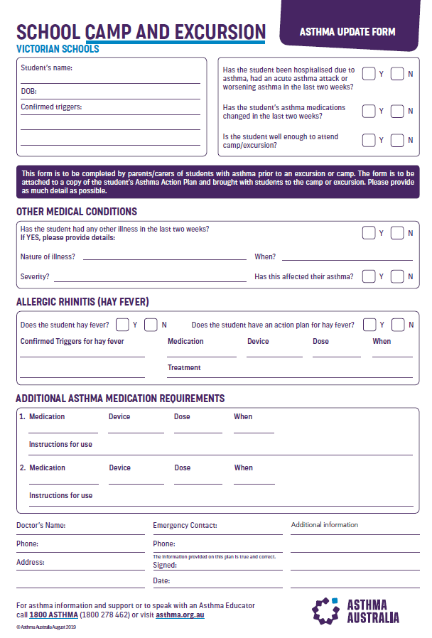

Action Plan – Allergic Reactions
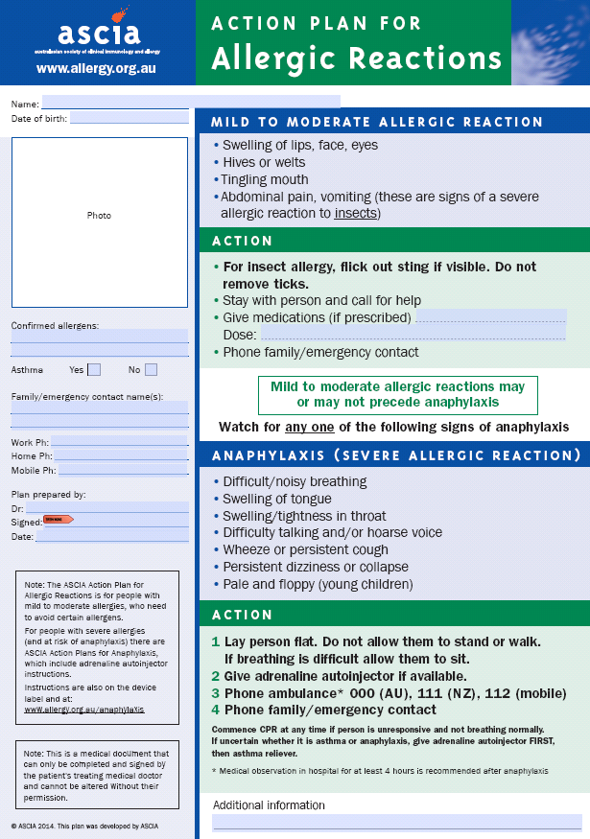

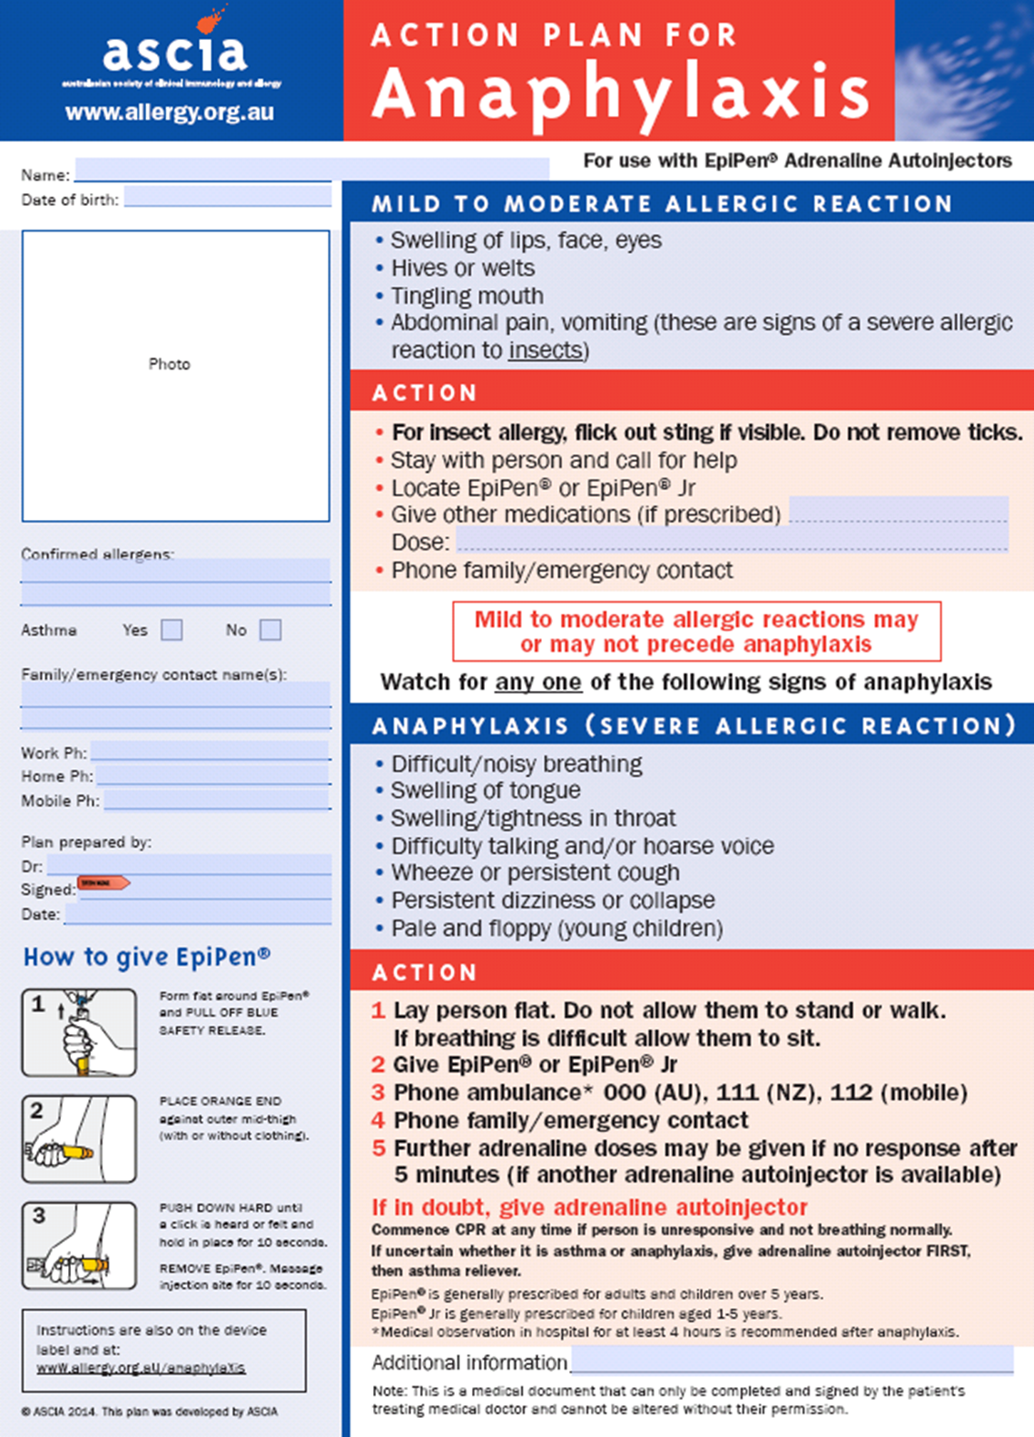
Action Plan – Anaphylaxis Reactions

Personal Clothing and Equipment
This list provides information on the types of the clothing and other essentials that you should bring. It also outlines the equipment supplied by 15 Mile Creek.

Clothing  o 1 set of thermal underwear (top and bottom)  o 2 warm jumpers (polar fleece or woollen preferred)  o Vest (a great extra)  o 3 pairs of shorts  o Tracksuit pants/leggings (2 pairs)  o 5 T-shirts  o Bathers  o Long sleeved shirt (sun protection)  o Solid walking boots or sneakers for activities (must be worn in). Not slip-ons  o Comfortable shoes (for around camp).  o Old runners (not slip-ons or thongs) or wet shoes for water activities.  o Underwear and socks – enough for 12 days (can do some washing). Hiking socks should be long and warm.  o Pyjamas  o Warm gloves  o Beanie  o Sunhat (15 Mile Creek can supply one)  o Spare comfortable clothes to wear around the school campus for the 4 days before and 3 days after the journey. | Other Items  o Sunglasses, sunscreen & lip balm  o Drink bottle  o Torch (small with spare batteries)  o Personal medical requirements  o Book for personal reading  15 Mile Creek Supplied Gear  o Fitted sheet  o Waterproof jackets  o Waterproof over pants  o Gloves  o Lunch box and drink bottle  o Day-packs  o Specialist equipment (tent, sleeping bag, sleeping mat, backpack, helmet etc.) are all provided.
Toiletries  o Soap, toothbrush, toothpaste, hairbrush, shampoo and conditioner | Linen  o Sleeping Bag for sleeping indoors at 15 Mile Creek, (an Alpine Sleeping Bag will be provided by 15 Mile Creek for the canoe journey)  o 1 pillow  o 2 towels  o Small personal towel/face washer for the journey

Please Note:
• Schools who attend late Term 2 or early Term 4 (possible winter conditions) should make sure to bring extra warm clothing to their program.
• All personal items and luggage should be clearly marked with the owner's name. The Department of
Education and Training does not hold insurance for personal property brought to schools and it has no capacity to pay for any loss or damage to such property.
• Try to utilise clothes and other items you have at home rather than buying anything special for the program.
• Outdoor School Bogong is a Sun smart School. Students are encouraged to wear a hat and clothing with long sleeves and collars, to wear suitable sunglasses and to apply sunscreen.
• Students are not to bring aerosol propellant cans e.g. deodorant sprays.

Sample Timetable

 | group | AM | PM | Evening
Monday | 1 | Arrive and Group leader briefing, group games | Team Initiative | What is Future makers?
 | 2 |  | Team Initiatives
Tuesday | 1 | Journey preparation | Bike Ride | Flying fox and navigation
 | 2 | Canoe Dam | Bike Ride | Paddle Making
Wednesday | 1 | Land Use examples tour |  | Paddle Making
 | 2 | Land use examples tour |  | Flying fox and navigation
Thursday | 1 | Canoe Dam | Journey Preparation | Sustainable Living Actions / final Journey Prep. Thankyou letters for land holders
 | 2 | Journey Preparation | Journey Preparation | Sustainable Living Actions / Final Journey Prep. Thankyou letters for land holders
Friday |  | Journey | Journey | Journey
Saturday |  | Journey | Journey | Journey
Sunday |  | Journey | Journey | Journey
Monday |  | Journey | Journey | Journey
Tuesday |  | Journey | Journey | Movie Night (North of the Sun)
Wednesday | 1 | Elective activities / Trip clean up  Each group to decide with their GT what they would like to do. | Water testing  Journey reflection / Journal Work | Concept mapping (ecosystems)  initiative Activities
 | 2 | Water testing  Journey reflection / Journal Work | Elective activities / Trip clean up  Each group to decide with their GT what they would like to do. | Concept mapping (ecosystems)  initiative Activities
Thursday | 1 | River day | River day | Pictures/ slide show / what happens back at school now. pizza making
 | 2 | River day | River day | pictures/ slide show / what happens back at school now. pizza making
Friday | 1 | Reflection / sustainable action / where to from here | Students leave at 1pm

Home school teachers are responsible for the supervision of students
from 10pm till 7.30am each day.

General Information

Physical Fitness for the Program
Students will be involved in strenuous activity and it is strongly advised that students and visiting teachers undertake a planned comprehensive fitness program as part of their preparation for their program. This may be incorporated into the schools Health and PE curriculum leading up to the 15 Mile Creek Experience.

Accommodation
Students and visiting teachers (VT’s) are accommodated in the two dormitories. 18 students & two visiting teachers can be accommodated in each dormitory. Dormitories are furnished with bunk beds, mattress, and cover sheet. Students and VTs are required to bring their own sleeping bag and pillow. All buildings are heated and facilities include bathrooms, indoor and outdoor recreation areas, drying rooms and dining room. Facilities (i.e. wheelchair ramps and specialised bathrooms/toilets) are provided to some accommodation for students with physical disabilities.

Catering
The Campus employs a chef and assistant who provide all meals and specifically cater for the tastes and appetites of teenagers. For catering purposes, the actual numbers of students and staff from each school needs to be sent to the Campus two weeks in advance with any special dietary requirements.

Transport
Schools are required to arrange for return transport between their school and 15 Mile Creek. Local transport during the program will be in Outdoor School vehicles.

Sick Students
Should a student be unable to take part in the program, then a visiting teacher may be required to supervise them at the Campus. 15 Mile Creek has a sick bay for dealing with first aid needs.

Telephone
Inward phone calls are received between 8.30am and 4.30pm. Outgoing calls may be made any convenient time by staff or students if needed, however; Students are discouraged from calling or receiving calls during the program.
15 Mile Creek has an answering machine at times when the office is unattended. All 15 Mile teachers have communications equipment for safety during program.

Emergency Telephone Numbers

Emergency Telephone Numbers

15MC (Office) | 03 5766 6247
15 MC (After Hours – Kitchen) | 03 5766 6137
Principal – Tony Keeble | 0417 541 732
15MC Principal – Rhys Evans | 0428 789 338

DET Office of Emergency Management – 24 hours 03 9589 6266

Reports
At the conclusion of the program, 15 Mile Creek teachers will write reports for each student including standards achieved according to the National Curriculum, and student personal goals.

Curriculum

Future Maker Curriculum
Below is a representation of the major components of the curriculum attached to the program.

