Outdoor School – 15 Mile Creek
Parent Consent Form — Valid 2023

Student’s Full Name: ______________________________________________________________________________________

Parent/Guardian Consent – please circle response below as appropriate – (if left blank we will assume yes is the response):
The information about your child/dependant and family collected through this Enrolment Form will only be shared with school staff who need to know to enable our school to educate or support your child/dependant, or to fulfil legal obligations including duty of care, anti-discrimination law and occupational health and safety law. The information collected will not be disclosed beyond the Department of Education and Training without your consent, unless such disclosure is lawful. For more about information-sharing and privacy, see our school’s privacy policy: Data will be kept permanently as per the 2018 Retention and Disposal Authority for Records of School Records 3.3.1 Summary Enrolment Records requires. The collection and use of the students personally identifiable information via consent forms provided within the handbook and stored via Cumulus is done in accordance with the Privacy and Data Protection Act 2014. Data will be kept permanently as per the 2018 Retention and Disposal Authority for Records of School Records 3.3.1 Summary Enrolment Records requires.
I agree to my child/dependant using the internet and computer network at 15 Mile Creek in accordance with the same internet student user’s agreement that applies at their current school. | Yes | No
I also consent to my child/dependant being photographed and/or visual images of my child/dependant being taken whilst at 15 Mile Creek by the DET. I also consent to these photos being used for use in the school’s publications, the school’s social media accounts and the school’s website, for publicity purposes without acknowledgment and without being entitled to any remuneration or compensation. | Yes | No
Is English your child/dependant’s main language? | Yes | No
Is your child/dependant of Aboriginal or Torres Strait Islander origin? | Yes | No
Has your child/dependant been away from home before? | Yes | No
I authorise the teacher in charge to administer paracetamol as per the Outdoor School protocol. | Yes | No
Subject to availability, I authorise Outdoor School to provide my child/dependant with a Rapid Antigen Test. | Yes | No
I understand that I will be required to immediately collect my child/dependant from Outdoor School if they display any covid symptoms or return a positive Rapid Antigen Test while on program. | Yes | No

I agree to my child/dependant's attendance at the Outdoor School – 15 Mile Creek on _______/________/__________ (Starting Date)
I also agree to them taking part in any excursion or activities arranged for students in connection with the school program. I have read the Parent/Guardian & Student Booklet and understand the program contains potentially hazardous activities in remote areas subject to natural hazards and severe weather.
I will notify the school if my child/dependant is in contact with any infectious disease within four weeks of departure date. In the event of any illness or accident, where it is impracticable to communicate with me, I authorise the teacher in charge to consent to my child/dependant receiving such medical or surgical treatment as may be deemed necessary. I accept responsibility for payment of any expenses thus incurred. In the event of my child/dependant being unable to accompany the rest of the group home due to ill health or accident I will make the necessary arrangements in liaising with the School Principal for their return.
I agree to ensure that my child/dependant’s mobile devices (phones, tablets, iPods etc.) remain at home whilst they attend this program.
Should my child/dependant violate the rules of the school to the extent that the teacher in charge in consultation with the Principal of Outdoor School 15 Mile Creek considers that they should be sent home, I agree to organise this withdrawal and fully cover the transport costs involved in this process.
________________________________________________________
Parent/Guardian's Full Name (please print)

________________________________________________________ __________________
Parent/Guardian's Signature Date

I have read the Outdoor School Student Code of Cooperation and I hereby undertake that while travelling to and from the school and while in attendance I shall behave in a good and proper manner and shall observe whatever rules are decided on as best for the welfare of all.

________________________________________________________ __________________
Student’s Signature Date
Cancellation or Withdrawal
The Department of Education and Training (DET) reserves the right to cancel a program for any reason. In the event of a student's application being withdrawn prior to the commencing date of the program the DET through the Principal reserves the right to make a refund only where a reasonable excuse for withdrawal is offered. No refund will be made where a student leaves during the program except in the case of illness, and then only on a pro rata basis.
Outdoor School – 15 Mile Creek

Medical Information Form — Valid 2023

This information is intended to assist Outdoor School in case of any medical emergency with your child/ward. All information is held in confidence.
School: |  |  |  |  |  |  |  | Year Level / Visiting Staff:

Student Full Name:
Student Date of Birth: |  |  |  |  |  | Student Gender: |  |  |  | Female |  |  |  | Male |  | Gender Diverse

Parent/Guardian Full Name:
Address: |  |  |  |  |  |  |  |  |  |  |  | Postcode:
Parent/Guardian Mobile Phone: |  |  |  |  |  |  |  |  | Other Phone:

Home Email Address:
Medicare No: |  |  |  |  | Valid to: |  |  |  |  |  | Child’s Number (eg. 2): 4):
Health Insurance Fund: |  |  |  |  | Member No: |  |  |  |  |  | Ambulance Subscriber: |  |  |  |  |  | Yes | No

Tick | Item | Details
 | Diabetes
 | Dietary Requirements
 | Dizzy Spells/Blackouts
 | Fits Of Any Type
 | Hay Fever
 | Heart Condition
 | Migraines
 | Physical Difficulties
 | Previous Injuries - When
 | Sleepwalking
 | Travel Sickness
 | Bedwetting
 | Other

Please tick the box on the left if your child/ward suffers any of the following:
 | Anaphylaxis | If ticked, you MUST attach the appropriate completed Anaphylaxis Action Plan.  Please state below who will be responsible for carrying the Epipen?  Responsible person is:
 | Allergies | If ticked, you MUST complete and attach the Allergic Reactions Action Plan
 | Asthma | If ticked, you MUST complete and attach Asthma Update Form along with your child’s  personal Asthma Action Plan.

Year of Last Tetanus Immunisation (If known):

Medication – Is your child/ward presently taking tablets and or medicine? YES / NO (If yes please detail below.)
Condition | Medication | Dosage | When given & instructions.
Swimming Ability: please tick the distance your child/ward can swim comfortably.
 | Cannot Swim |  | Weak Swimmer  (<50m) |  | Fair Swimmer  (50-100m) |  | Competent Swimmer  (100-200m) |  | Strong Swimmer (200m+)

____________________________________________________________ ___________________
Signature of Parent/Guardian:
DET requires this consent to be signed for all students and teachers attending school excursion

Asthma Update Form – School Camps & Excursions
Page 8 of 21

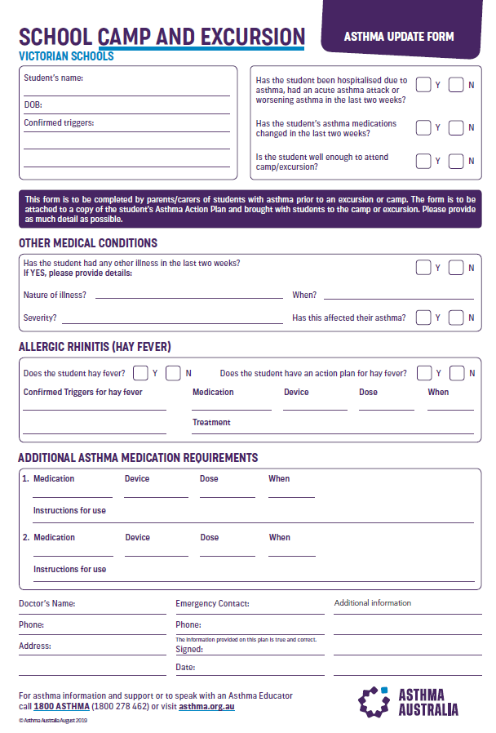

Action Plan - Allergic Reactions

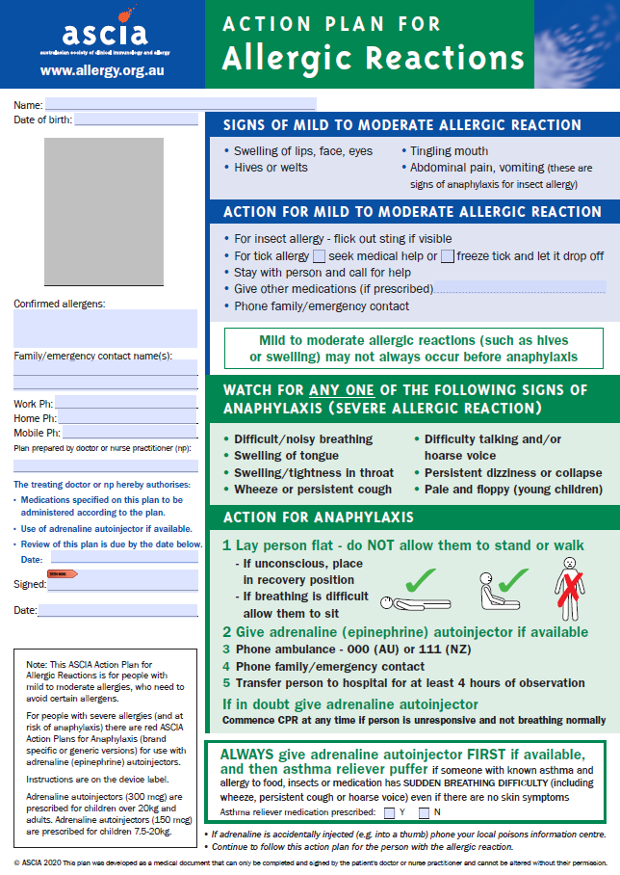
Action Plan - Anaphylaxis Reactions

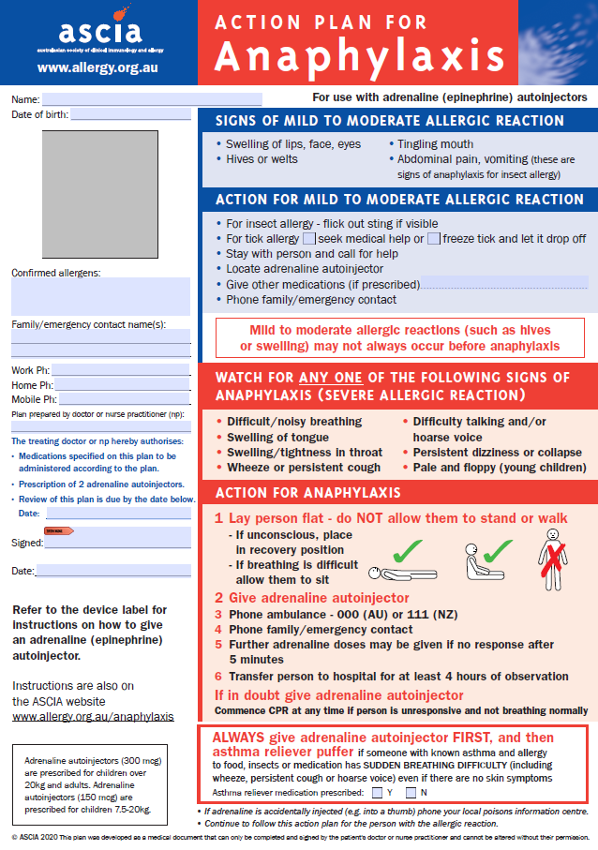

Personal Clothing and Equipment
This list provides information on the types of the clothing and other essentials that you should bring. It also outlines the equipment supplied by 15 Mile Creek.

Clothing
- 2 or three pairs of long pants (tracksuit/jeans)
- 1 or 2 windcheaters
- 1 or 2 pairs of shorts
- 1 pair of bathers
- Handkerchiefs
- Sunhat –broad brimed bucket – no caps
- 1 Pair Mittens or Gloves
- Beanie
- 2 Pairs of runners – (normal wear pair and old pair for aquatics)
- 2 or 3 long sleeve shirts or thermal tops
- 1 or 2 warm jumpers (polar fleece or woollen preferred)
- 3 or 4 T-shirts
- 4 sets (top and bottom) Underwear
- 4 Pairs Socks – (thick)
- 2 pair Pyjamas
- 1 warm parka or jacket

Toiletries
- Soap, toothbrush, toothpaste, hairbrush, roll-on deodorant (please do not bring spray deodorant), face washer.
- 2 Towels
Please Note:

*Schools who attend late Term 2 or early Term 4 (possible winter conditions) should make sure to bring extra warm clothing to their program.
*All personal items and luggage should be clearly marked with the owner's name. The DET does not hold insurance for personal property brought to schools and it has no capacity to pay for any loss or damage to such property.
*Try to utilise clothes and other items you have at home rather than buying anything special for the program.
*No money is required at 15 Mile creek, there is no facility at 15 Mile Creek to spend money.
*Outdoor School 15 Mile Creek is a Sunsmart School. Students are required to wear a hat from September to April (UV levels 3 or above). Students will also be encouraged to wear clothing with long sleeves and collars, to wear suitable sunglasses and to apply sunscreen.
*Students are not to bring deodorant sprays as they can set off the emergency fire alarm. Bring a roll-on deodorant instead.
*No personal ICT devices are permitted at 15 Mile Creek.

Linen
- Sleeping Bag for sleeping indoors at 15 Mile Creek, (where applicable an Alpine Sleeping Bag will be provided by 15 Mile Creek for overnight hikes)
- 1 pillow

Other Items
- Sunglasses & sunscreen
- Lip Balm
- Drink bottle
- Torch (small with new battery)
- Personal medical requirements
- Optional items - Book for personal reading, camera (not a phone or iPod), cards, games, thongs & insect repellent

15 Mile Creek Supplied Gear
- Fitted sheet
- Waterproof jackets
- Waterproof over pants
- Lunch box and drink bottle
- Day-packs
- Specialist equipment (tent, sleeping bag, backpack, helmet etc.) are all provided

