Outdoor School
ABN: 27 819 095 091
outdoor.sch@edumail.vic.gov.au
1 Black Possum Road,
Bogong, Victoria, 3699
P: 03 5754 1732 F: 03 5754 1735

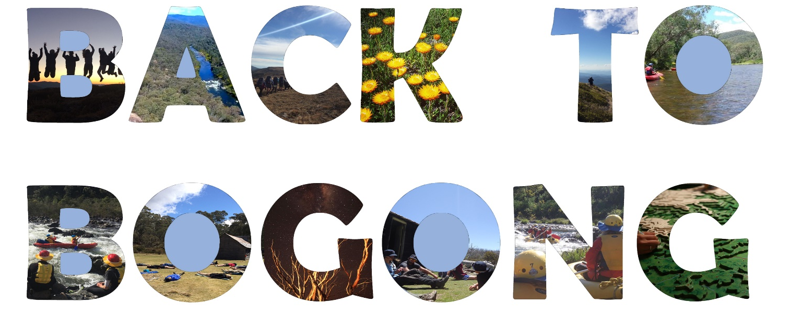

Information Booklet

An online version of this booklet can be downloaded at www.outdoorschool.vic.edu.au
This Parent/Guardian & Student Booklet can be translated into various languages using the ‘Translate’ icon in the Review tab when opening in word.

About the Programs
The 2019 Programs are scheduled for Sunday 17th November – Saturday 23rd November.
The extension programs began to provide students with the opportunity to further explore the Alpine environment, extend their outdoor skills, leadership skills and build independence. This is an opportunity for students to participate in a challenging five-day expedition style program in the Alpine environment and share this with other like-minded young people from across the state.

Summits Walk – 5 day hike
A journey on foot over 5 days & 4 nights spending time on the spectacular Bogong High Plains. The Summits Walk will challenge you to step outside your comfort zones, to build your independence and to work with others to camp in the Alpine Environment. The summits reached will include some of Victoria’s highest peaks: Mt Cope, Mt Nelse, Spion Kopje and Mt Bogong

Hike & Raft - 3-day hike & 2 days paddling
A journey over 5 days which includes 3 days hiking and 2 days white water rafting. The Hike & Raft is an opportunity to gain new experiences; hiking, camping and white water paddling. You will get plenty of opportunities to build teamwork skills. Hike accross the Bogong High Plains, visiting Mt Nelse on the way, before descending to the valley, where we will meet & paddle along the beautiful Mitta River

Applications
Any student currently enrolled in a Victorian government high school, in years 8 to 11 is eligible to apply. Applications are to be submitted via the following link: https://www.surveymonkey.com/r/NNLB3DP
Applications close: October 18th. Applicants will be contacted regarding their acceptance soon after.

Acceptance
There are a maximum number of 20 places available over all of the Extension Programs this year. There is also a minimum number for each program in order to make it viable. Every effort will be made to match students to their preferred program. However, if this is not possible to due to numbers, the applicant will be consulted and offered another program. In the case that we have more applicants than places, selection will be based on their written application. If a student misses out on their 1st preference and wishes to apply the following year they will be given priority for their preference.

Once accepted, the Extension Program Coordinator will be in contact with the students to ensure they are well prepared, finalise transport arrangements and to answer questions. It is important that students nominate an email address on their application form for this correspondence to occur.

Logistics

Timing
Students will arrive at Bogong on Sunday afternoon. Sunday evening will be spent getting to know other group members, and getting equipment organised. Students spend Sunday night at the dorm accommodation onsite. The journey itself will take place from Monday to Friday. On Friday night the groups will return and Friday we will again stay at the onsite accommodation, and enjoy a relaxed evening of celebration where students can reflect and share stories with each other. Students will finish returning equipment on Saturday morning, then

Transport
There are two options for transport. Students can either be dropped directly at our Bogong Campus on the Sunday afternoon, can be collected from the Wodonga Railway Station.

- Wodonga Railway Station - Students are responsible for arranging their own transport to Wodonga Railway Station (There is a train from Melbourne arriving at approximately 3:30pm). Outdoor School Bogong will provide transport from Wodonga Railway Station at approximately 3:45pm to Bogong on the Sunday and return students to Wodonga Railway Station on the following Saturday afternoon by 12:30pm (there is a returning train at approx. 1:00pm)

- Drop Off - Students can be driven by their parents to the Outdoor School – BOGONG CAMPUS at Bogong Village. In that case, the drop-off and pick up times are as follows: Sunday drop off: 5pm, Saturday morning pick up at 10am.

Cost
$140 per student. This covers all costs including, transport from Wodonga railway station, equipment hire, food, accommodation and maps. Full payment will be requested on confirmation, to be paid by the 8th of November.

Catering
Students will be provided with nutritious food from their arrival on Sunday afternoon, throughout the journey, until the following Saturday. Students will share food with a tent partner, which will include all basics and some extras. Any dietary requirements must be indicated on the medical form.

Equipment Requirements
Outdoor School Bogong will provide students with all the specialised equipment required for their journey. However, students will need to prepare their own clothing, appropriate for Alpine conditions. A full list of equipment taken on the trips is included in this information package and the clothing the student must supply is indicated.

Student Supervision
Students will be in the care of Outdoor School teaching staff at all times during their stay at Bogong, travel to and from the centre and during the expeditions. The expeditions will operate within Department of Education guidelines and staff to student ratios.

Other Important Parent/Guardian Information
The program will contain activities and events which are different from those experienced at school. Qualified and experienced teachers are responsible for the supervision and teaching of all adventure activities and necessary precautions are taken to minimise the possibility of injury.

Parents/guardians should understand however, that all the listed activities do carry risk of physical injury and that accidents can, and do occur. However, Outdoor School has an active and ongoing risk management program whose objective is to provide a safe and effective environment for students and staff.

Below is a brief description of some activities that maybe in your program. If you wish to view students participating in activities, please refer to our website. Many of the activities are conducted in remote and rugged locations and in environments subject to severe weather and other natural hazards. In the event of injury or illness, access to communications or emergency services may be limited or not available for significant periods of time. This may result in delays in injured or sick group members accessing more definitive care.

White Water Rafting - This activity involves students paddling inflatable rafts on white water rapids, on rivers up to a grade 3 (moderate) standard. Students may be in a boat with an adult guide, or in a ‘self-guided’ boat, supervised by guides in support craft, depending on river conditions and educational goals. Rivers accessed include the Mitta Mitta and Snowy River, and some sections of these rivers are remote and difficult to access via vehicle or on foot.

Overnight Bushwalk - Bushwalks are normally conducted on the Bogong High Plains. Students hike in groups of 12, accompanied by one Bogong Teacher and one Visiting Teacher. Walks can visit a number of historic cattleman’s huts and environmentally sensitive sites en route. Students cook for themselves using lightweight stoves under supervision. Bushwalks are preceded by a hike preparation session where students discuss the bushwalk and are given information, training, equipment, and food required for a safe and enjoyable experience.

Emergency Telephone Numbers
Bogong Campus (Office) | 03 5754 1732 | Bogong Campus (Fax) |  | 03 5754 1735
Principal – Tony Keeble | 0417 541 732 | Campus Principal – Roger Blackwell |  | 0417 202 578
DET Office of Emergency Management – 24 hours |  |  | 03 9589 6266

Privacy, Student Engagement, Mandatory Reporting & Child Safe Policies
Outdoor School has privacy, student engagement, mandatory reporting and child safe policies. These are available on the schools website at http://www.outdoorschool.vic.edu.au/policies/3699/

Student Code of Cooperation

Guiding Principles
- To ensure that the rights of all individuals are protected whilst at the school, and to and from the school.
- To establish the best possible learning environment.
- To ensure that breaches of the code of cooperation are treated in a fair and consistent manner and within the expectations of staff and students.

Rights | Responsibilities & Expectations
All individuals and their property are to be valued and treated with respect. | All students should treat one another, staff and property with respect.
All individuals have the right to a safe, secure and cooperative working environment in which participation, risk taking and confronting challenges are encouraged. | All students should act and behave in a way which does not endanger, intimidate or interfere with the participation of others.
All individuals have the right to privacy. | All students should respect others rights to privacy.
Staff should be able to perform their duties in an atmosphere of order and cooperation. | Students should comply with instructions given by any members of staff and should willingly participate in the daily routine of the School.
Staff, students and the natural environment have the right to exist in a healthy and environmentally considerate atmosphere. | All students should conduct themselves in a healthy and environmentally friendly manner towards other students, staff and the natural environment.
Bogong expects support from all students, parents/guardians and staff in implementing this Code of Cooperation. | All students should behave according to this code and accept the consequences if it is breached. All staff should fairly, reasonably and consistently implement this code. Staff and parents/guardians of participating schools should support Bogong in implementing the Code of Cooperation.

Specific Rules at the School
To respect the rights and expectations of all individuals at the school the following forms of behaviour are considered a breach of the code and are therefore unacceptable:
- Bringing cigarettes, alcohol, non-prescribed drugs, offensive weapons, and pornographic material.
- Using language which is offensive, sexist or racist.
- Fighting, bullying (physical, verbal, indirect or cyber) or any other forms of aggressive behaviour.
- Being in the lodges/room of a person of the opposite gender.
- Being in another student’s room without permission.
- Leaving Bogong Campus boundaries without permission.
- Behaving in a manner which damages or vandalises the property of others or the environment.
- Climbing of trees, buildings or other structures without teacher supervision.
- Students bringing deodorant sprays.

Personal ICT hardware such as phones, iPods and tablets are not to be brought to Bogong.
To maximise student learning we expect students to disconnect from all mobile devices for their time at Bogong. This allows students to engage with their peers, and the outdoor experience. Any mobile devices that are brought to Bogong, will be collected by Visiting Teachers upon arrival and stored in a secure place. If needing more information you may access a copy of our Personal Mobile ICT Devices Policy from our website via the following link http://www.outdoorschool.vic.edu.au/policies/3699/

Implementation Process
The School has developed levels of appropriate responses and sanctions. Any breach of the Code of Cooperation will initiate a restorative approach. The staff will decide the appropriate level of action.

Personal Clothing and Equipment

This list provides information on the types of the clothing and other essentials that you should bring. It also outlines the equipment supplied by Bogong.

Clothing
- 1 set of thermal underwear (top and bottom)
- 2 warm jumpers (polar fleece or woollen preferred)
- 3 pairs shorts
- 2 pair of pants (tracksuit or quick dry)
- 4 T-shirts
- Bathers (Oct-April)
- Long sleeved shirt (sun protection)
- Solid walking boots or sneakers for activities (must be worn in). Not slip-ons
- Comfortable shoes (for around camp).
- Old runners/sandals for wet activities (not thongs).
- 5 pairs underwear
- 5 pairs socks (hiking socks should be long and warm).
- Pyjamas
- Warm gloves
- Beanie
- Sunhat (Broad-brimmed)

Toiletries
- Soap, toothbrush, toothpaste, hairbrush, roll-on deodorant (don’t bring spray deodorant).

Linen
- Sleeping Bag for sleeping indoors at Bogong, (where applicable an Alpine Sleeping Bag will be provided by Bogong for overnight hikes)
- 1 pillow
- 2 towels

Other Items
- Sunglasses & sunscreen
- Drink bottle
- Torch (small with new battery)
- Personal medical requirements
- Book for personal reading

Bogong Supplied Gear
- Fitted sheet
- Waterproof jackets
- Waterproof over pants
- Gloves
- Lunch box and drink bottle
- Day-packs
- Specialist equipment (tent, sleeping bag, backpack, helmet etc.) are all provided.

Please Note:
- Schools who attend late Term 2 or early Term 4 (possible winter conditions) should make sure to bring extra warm clothing to their program. A day skiing can sometimes be incorporated into a program at these times.
- All personal items and luggage should be clearly marked with the owner's name. The DET does not hold insurance for personal property brought to schools and it has no capacity to pay for any loss or damage to such property.
- Try to utilise clothes and other items you have at home rather than buying anything special for the program.
- If travelling more than 2 hours $20 may be of value for meals en route. There is no facility at Bogong to spend this money.
- Outdoor School Bogong is a Sunsmart School. Students are encouraged to wear a hat and clothing with long sleeves and collars, to wear suitable sunglasses and to apply sunscreen.
- Students are not to bring deodorant sprays as they can set off the emergency fire alarm. Bring a roll-on deodorant instead.

